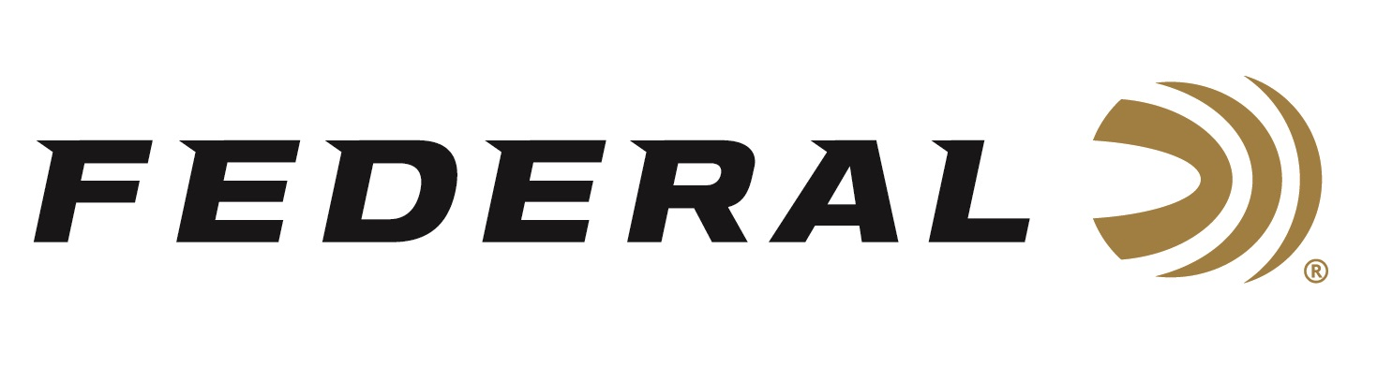

FOR IMMEDIATE RELEASE

Outdoor Enthusiast Remi Warren on “It’s Federal Season” Podcast

ANOKA, Minnesota – July 15, 2021 – Remi Warren just doesn’t talk about being an outdoorsman, he lives the lifestyle to its maximum! His adventurous spirit at a young age motivated him to learn about hunting and conservation. He has propelled that passion into a career of outfitting and guiding, media production, and as an evangelist for the outdoor lifestyle.

Episode #23 “Completely Immersed”
https://www.federalpremium.com/this-is-federal/podcast/

“Remi Warren is what many of us aspire to be,” stated Brian Kelvington, Director, Media at Federal Ammunition. “He not only makes his living being an outdoorsman, but he is also completely immersed in it as he reports he spends around three-hundred days a year in the wide opens spaces hunting and fishing,” said Kelvington. “It’s a feeling of adventure,” states Warren about his love of the lifestyle. “Every day is different whether I’m guiding or hunting on my own and it pushes your hunting skills.”

On this episode, Warren dives into fitness, trip preparation, as well as some cooking recommendations as he is a master in the kitchen. Before ending the conversation, Warren also gives some advice and recommends a unique tool to assist when judging a deer. A great conversation with some helpful hints on a variety of topics all outdoorsmen and women can use.

For this episode, besides listening on the Federal Premium website or Talk North podcast network, you can also subscribe to Federal Ammunition’s YouTube channel (https://www.youtube.com/user/federalpremiumammo) and tune in for the discussion.

Federal Ammunition can be found at dealers nationwide or purchased online direct from Federal. For more information on all products from Federal or to shop online, visit www.federalpremium.com.

Press Release Contact: JJ Reich
Senior Manager – Press Relations
E-mail: VistaPressroom@VistaOutdoor.com

About Federal Ammunition
Federal, headquartered in Anoka, MN, is a brand of Vista Outdoor Inc., an outdoor sports and recreation company. From humble beginnings nestled among the lakes and woods of Minnesota, Federal Ammunition has evolved into one of the world's largest producers of sporting ammunition. Beginning in 1922, founding president, Charles L. Horn, paved the way for our success. Today, Federal carries on Horn's vision for quality products and service with the next generation of outdoorsmen and women. We maintain our position as experts in the science of ammunition production. Every day we manufacture products to enhance our customers' shooting experience while partnering with the conservation organizations that protect and support our outdoor heritage. We offer thousands of options in our Federal Premium and Federal® lines-it's what makes us the most complete ammunition company in the business and provides our customers with a choice no matter their pursuit.

